

Handout - Enterprise Manager or SSMS

Is Access Database a RDBMS?
Access fulfills all rules of CODD, so from this point of view, yes it’s truly an RDBMS. However, many people can contradict it as a large community of Microsoft professionals think that Access is not an RDBMS.

- What is SQL SERVER Express 2005 Edition?
Twist: What is the difference between SQL SERVER Express 2005 and MSDE 2000?
Note: Normally comparison is when the product is migrating from one version to other version. When SQL SERVER 7.0 was migrating to SQL 2000, asking differences was one of the favorite questions.
SQL SERVER Express edition is a scaled down version of SQL SERVER 2005 and the next evolution of MSDE.
Listed below are some major differences between them:
- MSDE maximum database size is 2GB while SQL SERVER Express has around 4GB.
- In terms of programming language support MSDE has only TSQL, but SQLSERVER Express has TSQL and .NET. In SQL SERVER Express 2005, you can write your stored procedures using .NET.
- SQL SERVER Express does not have connection limitation, which MSDE had and was controlled through the workload governor.
- There was no XCOPY support for MSDE, SQL SERVER Express has it.
- DTS is not present in SQL SERVER express while MSDE has it.
- SQL SERVER Express has reporting services while MSDE does not.
- SQL SERVER Express has native XML support and MSDE does not.
Note: Native XML support means now in SQL SERVER 2005:
- You can create a field with data type XML.
- You can provide SCHEMA to the SQL SERVER fields with XML data type.
- You can use new XML manipulation techniques like XQUERY also called as XML QUERY.
There is a complete chapter on SQL SERVER XML Support, so till then this will suffice.
Summarizing: The major difference is the database size (2 GB and 4 GB), support of .NET support in stored procedures and native support for XML. This much can convince the interviewer that you are clear about the differences.

- What is the Difference between SQL SERVER 2000 and 2005?
Twist: What is the difference between Yukon and SQL SERVER 2000?
Note: This question will be one of the favorites during SQL SERVER interviews. I have marked the points which should be mentioned by developers as PG and DBA for Database Administrator.
Following are some major differences between the two versions:
- (PG) The most significant change is the .NET integration with SQL SERVER 2005. Stored procedures, user-defined functions, triggers, aggregates, and user-defined types can now be written using your own favorite .NET language (VB.NET, C#, J# etc.). This support was not there in SQL SERVER 2000 where the only language was T-SQL. In SQL 2005, you have support for two languages T-SQL and .NET.
- (PG) SQL SERVER 2005 has reporting services for reports which is a newly added feature and does not exist for SQL SERVER 2000. It was a separate installation for SQL Server 2000.
- (PG) SQL SERVER 2005 has introduced two new data types varbinary (max) and XML. If you remember in SQL SERVER 2000, we had image and text data types. Problem with image and text data types is that they assign the same amount of storage irrespective of what the actual data size is. This problem is solved usingvarbinary (max) which acts depending on amount of data. One more new data type is included XML which enables you to store XML documents and does schema verification. In SQL SERVER 2000, developers usedvarchar or text data type and all validation had to be done programmatically.
- (PG) SQL SERVER 2005 can now process direct incoming HTTP request without IIS Web server. In addition, stored procedure invocation is enabled using the SOAP protocol.
- (PG) Asynchronous mechanism is introduced using server events. In Server event model the server posts an event to the SQL Broker service, later the client can come and retrieve the status by querying the broker.
- For huge databases, SQLSERVER has provided a cool feature called “Data partitioning”. In data partitioning, you break a single database object such as a table or an index into multiple pieces. But for the client application accessing the single database object, “partitioning” is transparent.
- In SQL SERVER 2000, if you rebuilt clustered indexes even the non-clustered indexes where rebuilt. But in SQL SERVER 2005 building the clustered indexes does not build the non-clustered indexes.
- Bulk data uploading in SQL SERVER 2000 was done using BCP (Bulk copy program’s) format files. Now in SQL SERVER 2005 bulk, data uploading uses XML file format.
- In SQL SERVER 2000 there were maximum 16 instances, but in 2005 you can have up to 50 instances.
- SERVER 2005 has support of “Multiple Active Result Sets” also called as “MARS”. In previous versions of SQL SERVER 2000 in one connection, you could only have one result set. Now in one SQL connection, you can query and have multiple results set.
- In previous versions of SQL SERVER 2000, system catalog was stored in the master database. In SQL SERVER 2005, it’s stored in a resource database which is stored as sys object. You cannot access the sys object directly as in the older version we were accessing the master database.
- This is one of the hardware benefits which SQL SERVER 2005 has over SQSERVER 2000 – support of hyper threading. WINDOWS 2003 supports hyper threading; SQL SERVER 2005 can take advantage of the feature unlike SQL SERVER 2000 which did not support hyper threading.
Note: Hyper threading is a technology developed by INTEL which creates two logical processors on a single physical hardware processor.
- SMO will be used for SQL Server Management.
- AMO (Analysis Management Objects) to manage Analysis Services servers, data sources, cubes, dimensions, measures, and data mining models. You can mapm AMO in old SQL SERVER with DSO (Decision Support Objects).
- Replication is now managed by RMO (Replication Management Objects).
Note: SMO, AMO and RMO are all using .NET Framework.
- SQL SERVER 2005 uses current user execution context to check rights rather than ownership link chain, which was done in SQL SERVER 2000.
Note: There is a question on this later see for execution context questions.
- In previous versions of SQL SERVER the schema and the user name was same, but in current, the schema is separated from the user. Now the user owns schema.
Note: There are questions on this, refer “Schema” later.
Note: Ok below are some GUI changes.
- Query analyzer is now replaced by query editor.
- Business Intelligence development studio will be used to create Business intelligence solutions.
- OSQL and ISQL command line utility is replaced by SQLCMD utility.
- SQL SERVER Enterprise manager is now replaced by SQL SERVER Management studio.
- SERVER Manager which was running in system tray is now replaced by SQL Computer manager.
- Database mirror concept is supported in SQL SERVER 2005, which was not present in SQL SERVER 2000.
- In SQL SERVER 2005 Indexes can be rebuilt online when the database is in actual production. If you look back in SQL SERVER 2000, you cannot do insert, update, and delete operations when you are building indexes.
- (PG) Other than Serializable, Repeatable Read, Read Committed, and Read Uncommitted isolation levels, there is one more new isolation level “Snapshot Isolation level”.
Note: We will see “Snapshot Isolation level” in detail in the coming questions.
Summarizing: The major significant difference between SQL SERVER 2000 and SQL SERVER 2005 is in terms of support of .NET Integration, Snap shot isolation level, Native XML support, handling HTTP request, Web service support and Data partitioning. You do not have to really say all the above points during an interview. A sweet summary and you will rock.

What are E-R diagrams?
E-R diagram also termed as Entity-Relationship diagram shows the relationship between various tables in the database. Example: Tables Customer and Customer Addresses have a one to many relationship (i.e. one customer can have multiple addresses) this can be shown using the ER diagram. ER diagrams are drawn during the initial stages of a project to forecast how the database structure will shape up. Below is a screen shot of a sample ER diagram of “Asset Management” which ships free with Access.

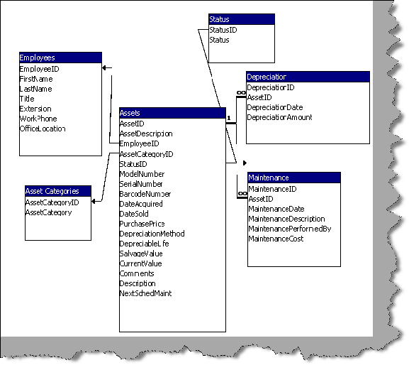

In which Files does SQL Server Actually Store Data?
Any SQL Server database is associated with two kinds of files: *.mdf and *.ldf. *.mdf files are actual physical database files where your data is stored finally. *.ldf (LOG) files are actually data, which is recorded from the last time data was committed in the database.

